Himadri Sekhar Tewari

IST 659

Project Deliverable 1 & Project Deliverable 2

**Database for an Online Pizza Company**

**Project Summary:**

I want to build a database for an online pizza company. It start with a guest customer entry details or new customer register first time in the webpage by providing the name, address, email and phone number. After successful registration, customer can select pizzas of different sizes and toppings limited to 10 toppings. Customer can select other products present from the product page and can increase or decrease the quantity or remove the item. Only one coupon can be added to an order. A coupon can be either order type or item type. After selecting one or more products and adding in cart, customer can choose the order destination as either carryout or delivery. After selecting the destination, customer can choose the order ready date as current date or future date or future time. After selecting the date/time, customer need to select payment methods (one or more payments are applicable). The different type of payment types is Cash or Credit Card. When selecting cash, customer need to enter only the amount. For credit cards, customer has to enter the card number, expiration date, CVV, name in the card, billing address. Once the card number is entered, card type will be auto selected and the correct card name will be displayed. Customer has the option to save a maximum of 3 cards in the customer account. After selecting the payments, customer has the option to review the order before confirmation. click on Confirm Order button and an order confirmation number is generated in the webpage and an email is sent to the customer in the registered/given email.

Question 1:

Use the database to find out the most popular product

Question 2:

Use the database to compare the sale of current year to last year

Question 3:

Comparison between guest and registered customer

|  |  |
| --- | --- |
| **Entity** | **Attribute** |
| Customer | CustomerID [ru]  Name [r]  Address[r]  Phone Number [r]  Email address [ru] |
| Product | ProductID [ru]  Product Name [r]  Product Type [r] |
| Coupon | CouponID [ru]  Coupon Name [r]  Description [r]  Coupon Type [r]  Coupon Details [r] |
| Order Source | OrderSourceID [ru]  Source Type [r] |
| Order Destination | OrderDestinationID [ru]  Destination Type [r] |
| Order Ready | OrderReadyID [ru]  Date [ru]  Time [r] |
| Payment Method | PaymentMethodID [ru]  PaymentType [r]  Amount [r]  TransactionType [r] |
| Card Payment Details | PaymentID [ru]  Name [r]  Card Type [r] |
| Customer Account | CustomerAccountID [ru]  Customer Name [r]  Card Type [r]  Card Number [r]  Billing Address [r] |
| Order Detail | OrderDetailID [ru]  Order Confirmation Number [ru]  Order Confirmation Date [ru]  Quantity [r]  Ordered Product [r] |

**Conceptual Model:**

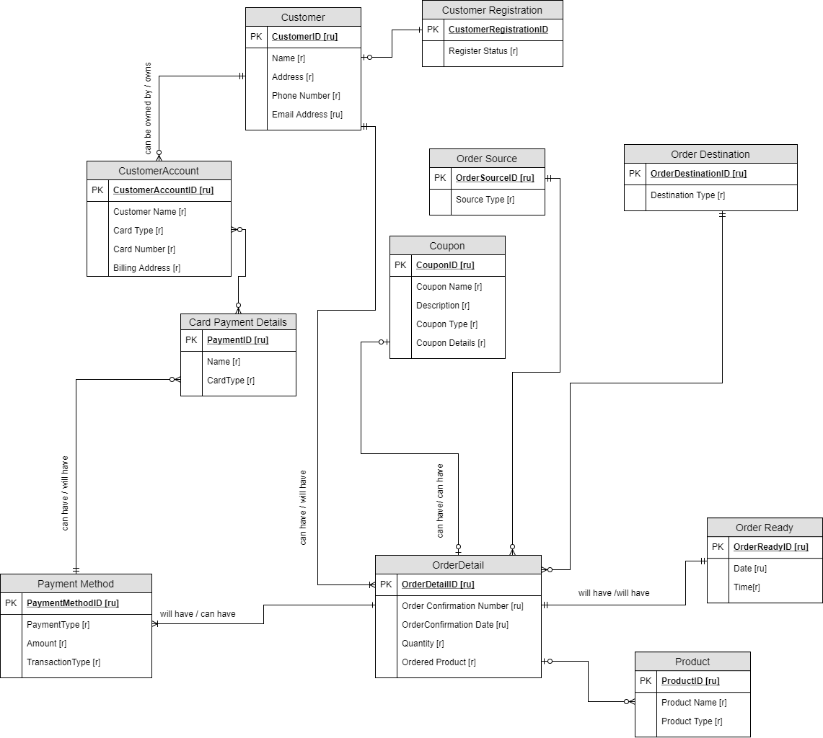

**Normalized Logical Model:**

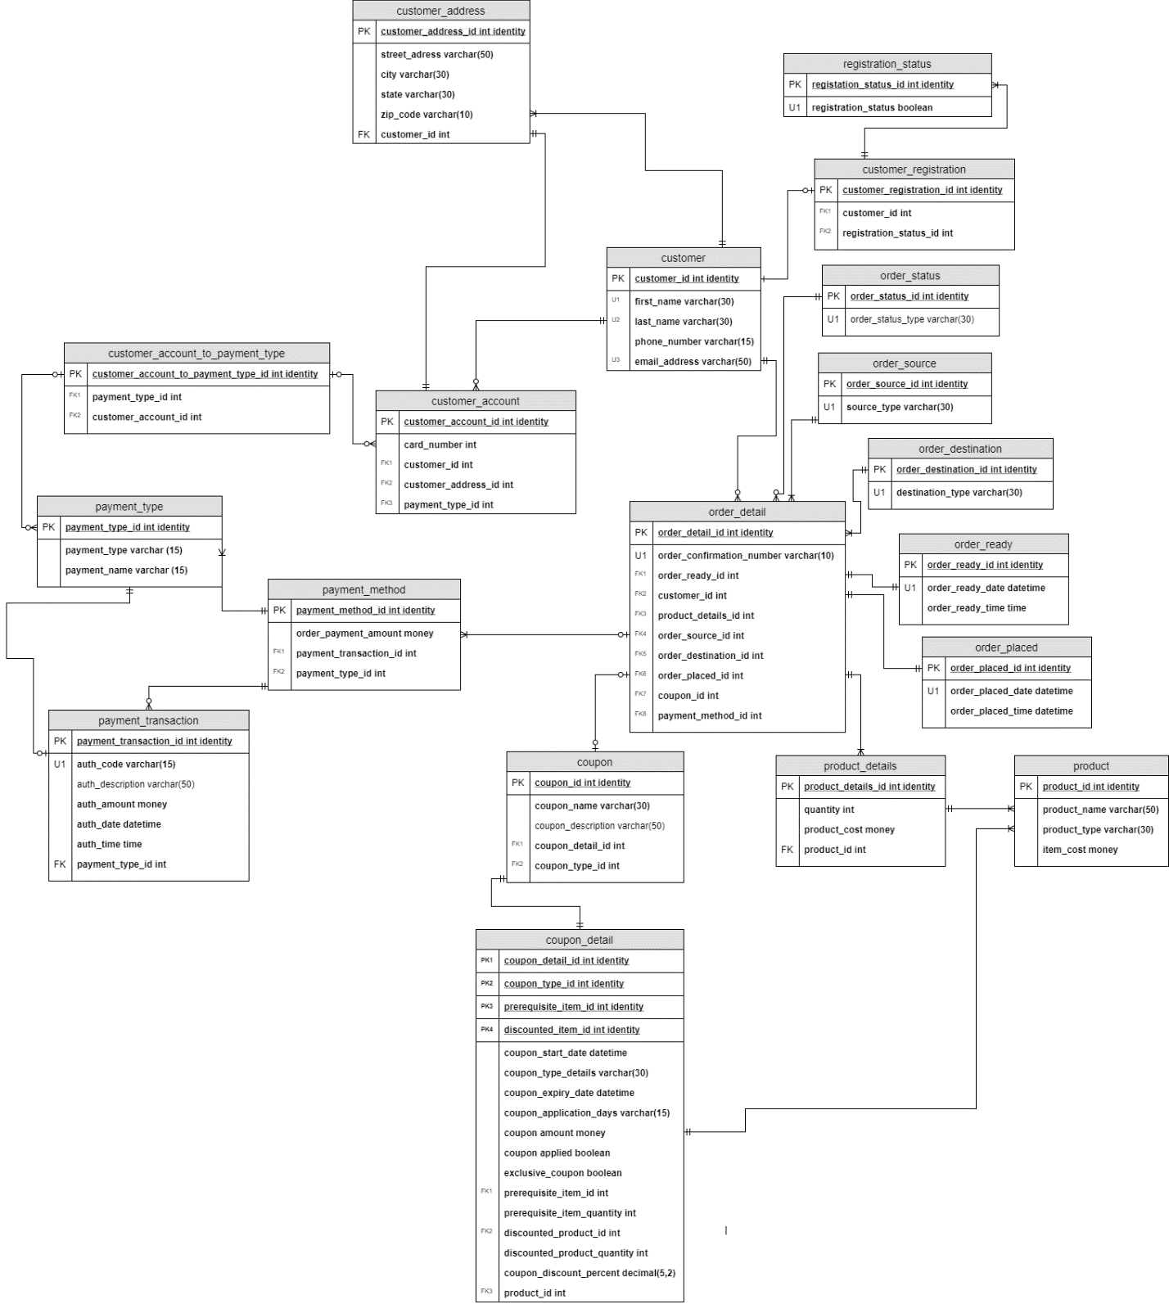**Project Deliverable 2:**

**SQL DDL Commands**

-- Creating customer table

create table customer(

customer_ID int identity

,first_name varchar(30) not null

, last_name varchar(30) not null

, phone_number varchar(15) not null

, email_address varchar(50) not null

-- Constraint on the customer table

constraint PK_customer primary key (customer_ID),

constraint U1_customer unique (first_name),

constraint U2_customer unique (last_name),

constraint U3_customer unique (email_address)

)

-- End creating customer table

-- Creating customer address table

create table customer_address(

-- Columns for customer address table

customer_address_ID int identity

,street_address varchar(50) not null

, city varchar(30) not null

, state varchar(30) not null

, zip_code varchar(10) not null

, customer_ID int not null

-- Constraints on the customer address table

constraint PK_customer_address primary key (customer_address_ID),

constraint FK1_customer_address foreign key (customer_ID) references customer(customer_ID)

)

-- End creating customer address table

-- Creating registration status table

create table registration_status(

-- Columns for registration status table

registration_status_ID int identity

, registration_status bit

-- Constraints on registration status table

constraint PK_registration_status primary key (registration_status_ID),

constraint U1_registration_status unique (registration_status)

)

-- End creating registration_status table

-- Creating customer registration table

create table customer_registration(

-- Columns for customer registration table

customer_registration_ID int identity

, customer_ID int not null

, registration_status_ID int not null

-- Constraints on customer registration table

constraint PK_customer_registration primary key (customer_registration_ID),

constraint FK1_customer_registration foreign key (customer_ID)

references customer(customer_ID),

constraint FK2_customer_registration foreign key (registration_status_ID)

references registration_status(registration_status_ID)

)

-- End creating customer registration table

-- Creating order source table

create table order_source(

order_source_ID int identity

, source_type varchar(30) not null

--constraints on order_source table

constraint PK_order_source primary key (order_source_ID),

constraint U1_order_source unique (source_type)

)

-- End creating order source table

-- Creating order status table

create table order_status(

order_status_ID int identity

, order_status_type varchar(30) not null

--constraints on order status table

constraint PK_order_status primary key (order_status_ID),

constraint U1_order_status unique (order_status_type)

)

-- End creating order status table

-- Creating order destination table

create table order_destination(

order_destination_ID int identity

, destination_type varchar(30) not null

--constraints on order destination table

constraint PK_order_destination primary key (order_destination_ID),

constraint U1_order_destination unique (destination_type)

)

-- End creating order destination table

-- Creating order ready table

create table order_ready(

order_ready_ID int identity

, order_ready_date datetime

, order_ready_time time

--constraints on order ready table

constraint PK_order_ready primary key (order_ready_ID),

constraint U1_order_ready unique (order_ready_date)

)

-- End creating order ready table

-- Creating order placed table

create table order_placed(

order_placed_ID int identity

, order_placed_date datetime

, order_placed_time time

--constraints on order placed table

constraint PK_order_placed primary key (order_placed_ID),

constraint U1_order_placed unique (order_placed_date)

)

-- End creating order placed table

-- Creating product table

create table product(

product_ID int identity

, product_name varchar(50) not null

, product_type varchar(30) not null

, item_cost money

--constraints on product table

constraint PK_product primary key (product_ID),

)

-- End creating product table

-- Creating product details table

create table product_details(

product_details_ID int identity

, quantity int not null

, product_cost money

, product_ID int

--constraints on product details table

constraint PK_product_details primary key (product_details_ID),

constraint FK_product_details foreign key (product_ID) references product(product_ID)

)

-- End creating product details table

-- Creating payment type table

create table payment_type(

payment_type_ID int identity

, payment_type varchar(15) not null

, payment_name varchar(15) not null

--constraints on payment type table

constraint PK_payment_type primary key (payment_type_ID),

)

-- End creating payment type table

-- Creating payment transaction table

create table payment_transaction(

payment_transaction_ID int identity

, auth_code varchar(15)

, auth_description varchar(50)

, auth_amount money

, auth_date datetime

, auth_time time

, payment_type_ID int

--constraints on payment transaction table

constraint PK_payment_transaction primary key (payment_transaction_ID),

constraint U1_payment_transaction unique (auth_code),

constraint FK_payment_transaction foreign key (payment_type_ID) references payment_type(payment_type_ID)

)

-- End creating payment transaction table

-- Creating payment method table

create table payment_method(

payment_method_ID int identity

, order_payment_amount money

, payment_transaction_ID int

, payment_type_ID int

--constraints on payment method table

constraint PK_payment_method primary key (payment_method_ID),

constraint FK1_payment_method foreign key (payment_transaction_ID)

references payment_transaction(payment_transaction_ID),

constraint FK2_payment_method foreign key (payment_type_ID)

references payment_type(payment_type_ID)

)

-- End creating payment method table

-- Creating customer account table

create table customer_account(

customer_account_ID int identity

, customer_ID int

, customer_address_ID int

, payment_type_ID int

--constraints on customer account table

constraint PK_customer_account primary key (customer_account_ID),

constraint FK1_customer_account foreign key (customer_ID)

references customer(customer_ID),

constraint FK2_customer_account foreign key (customer_address_ID)

references customer_address(customer_address_ID),

constraint FK3_customer_account foreign key (payment_type_ID)

references payment_type(payment_type_ID)

)

-- End creating customer account table

-- Creating customer account to payment type table

create table customer_account_to_payment_type(

customer_account_to_payment_type_ID int identity

, payment_type_ID int

, customer_account_ID int

--constraints on customer account to payment type table

constraint PK_customer_account_to_payment_type primary key (customer_account_to_payment_type_ID),

constraint FK1_customer_account_to_payment_type foreign key (customer_account_ID)

references customer_account(customer_account_ID),

constraint FK2_customer_account_to_payment_type foreign key (payment_type_ID)

references payment_type(payment_type_ID)

)

-- End creating customer account to payment type table

-- Creating order detail table

create table order_detail(

order_detail_ID int identity

, order_confirmation_number varchar(10) not null

, order_ready_ID int

, customer_ID int

, product_details_ID int

, order_source_ID int

, order_destination_ID int

, order_placed_ID int

, coupon_ID int

, payment_method_ID int

--constraints on order detail table

constraint PK_order_detail primary key (order_detail_ID),

constraint U1_order_detail unique (order_confirmation_number),

constraint FK1_order_detail foreign key (order_ready_ID)

references order_ready(order_ready_ID),

constraint FK2_order_detail foreign key (customer_ID)

references customer(customer_ID),

constraint FK3_order_detail foreign key (product_details_ID)

references product_details(product_details_ID),

constraint FK4_order_detail foreign key (order_source_ID)

references order_source(order_source_ID),

constraint FK5_order_detail foreign key (order_destination_ID)

references order_destination(order_destination_ID),

constraint FK6_order_detail foreign key (order_placed_ID)

references order_placed(order_placed_ID),

constraint FK7_order_detail foreign key (coupon_ID)

references coupon(coupon_ID),

constraint FK8_order_detail foreign key (payment_method_ID)

references payment_method(payment_method_ID)

)

-- End creating order detail table

-- Creating coupon detail table

create table coupon_detail(

coupon_detail_ID int identity

, coupon_type_ID int

, discounted_item_ID int

, coupon_start_date datetime

, coupon_type_details varchar(30) not null

, coupon_expiry_date datetime

, coupon_application_days varchar(15)

, coupon_amount money

, coupon_applied bit

, exclusive_coupon bit

, discounted_product_quantity int

, coupon_discount_percent decimal(5,2)

, product_ID int

--constraints on coupon detail table

constraint PK1_coupon_detail primary key (coupon_detail_ID),

constraint FK1_coupon_detail foreign key (product_ID)

references product(product_ID),

)

-- End creating coupon detail table

-- Creating coupon detail table

create table coupon_detail(

coupon_detail_ID int identity

, coupon_type_ID int

, discounted_item_ID int

, coupon_start_date datetime

, coupon_type_details varchar(30) not null

, coupon_expiry_date datetime

, coupon_application_days varchar(15)

, coupon_amount money

, coupon_applied bit

, exclusive_coupon bit

, discounted_product_quantity int

, coupon_discount_percent decimal(5,2)

, product_ID int

--constraints on coupon detail table

constraint PK1_coupon_detail primary key (coupon_detail_ID),

constraint FK1_coupon_detail foreign key (product_ID)

references product(product_ID),

)

-- End creating coupon detail table

-- Creating coupon table

create table coupon(

coupon_ID int identity

, coupon_name varchar(30) not null

, coupon_description varchar(50) not null

, coupon_detail_ID int

--constraints on coupon table

constraint PK_coupon primary key (coupon_ID),

constraint FK1_coupon foreign key (coupon_detail_ID)

references coupon_detail(coupon_detail_ID),

)

-- End creating coupon table

**More SQL DDL**

go

-- Stored Procedure to create new customer

create procedure new_customer(

@firstname varchar(30),

@lastname varchar(30),

@phonenumber varchar(15),

@emailaddress varchar(50)

) as

begin

declare @customerID int

-- Get the customer ID from the customer table and store it in @customerID

select @customerID = customer_ID from customer

where customer_ID = @customerID

-- Insert new customer record in customer table

insert into customer(first_name, last_name, phone_number,email_address)

values (@firstname, @lastname, @phonenumber, @emailaddress)

-- increment customerID using @@identity

return @@identity

end

exec new_customer 'Katrina','Adams','7876650091','kadams@syr.edu'

go

-- Stored Procedure to create customer address

alter procedure customeraddress(

@streetaddress varchar(50),

@city varchar(30),

@state varchar(30),

@zipcode varchar(10),

@customerID int

) as

begin

declare @customeraddressID int

/*

Get the customeraddress ID from the customer adress table

by joining the customerID of customer

table with customer address table

and store it in @customerID

*/

select @customeraddressID = customer_address_ID

from customer_address

join customer

on customer.customer_ID = customer_address.customer_ID

-- Insert new customer adress

insert into customer_address(street_address, city, state,zip_code, customer_ID)

values (@streetaddress, @city, @state, @zipcode, @customerID)

-- increment customerID using @@identity

return @@identity

end

go

-- Create view to see customer address and registration status

create view customer_registration_details as(

select customer.first_name

, customer.last_name

, customer_address.street_address

, customer_address.city

, customer_address.state

, customer_address.zip_code

, registration_status.registration_status

from customer

join customer_address

on customer.customer_ID = customer_address.customer_ID

join customer_registration

on customer_registration.customer_ID = customer.customer_ID

join registration_status

on registration_status.registration_status_ID = customer_registration.registration_status_ID

)

go

-- Create View to see product sold most

create view product_sold_details as(

select product.product_name

, product.product_type

, sum(product_details.product_cost) as product_cost

from product

inner join product_details

on product.product_ID = product_details.product_ID

group by product.product_name, product.product_type

)

select * from dbo.product_sold_details order by product_cost desc

select * from dbo.customer_registration_details order by registration_status desc

go

-- Create function to multiply quantity with product price

create function product_price(@quantity int, @itemcost money)

returns money as

begin

declare @returnvalue money

set @returnvalue = @quantity * @itemcost

return @returnvalue

end

go

-- Stored Procedure to create new payment method

create procedure new_payment_method(@paymenttransactionID int) as

begin

select @paymenttransactionID = payment_transaction_ID from payment_transaction

where payment_transaction_ID = @paymenttransactionID

-- Insert new data in payment method table

insert into payment_method(order_payment_amount, payment_transaction_ID, payment_type_ID)

values ((select auth_amount from payment_transaction

where payment_transaction_ID = @paymenttransactionID),

(select payment_transaction_ID from payment_transaction

where payment_transaction_ID = @paymenttransactionID),

(select payment_type_ID from payment_transaction

where payment_transaction_ID = @paymenttransactionID)

)

end

**SQL DML INSERT Statements**

--Insert status in registration status table

insert into registration_status(registration_status)

values (1)

-- Insert record in customer registation table

insert into customer_registration (customer_ID, registration_status_ID)

values(1, 2)

insert into customer_registration (customer_ID, registration_status_ID)

values(2, 2)

insert into customer_registration (customer_ID, registration_status_ID)

values(3, 2)

insert into customer_registration (customer_ID, registration_status_ID)

values(4, 1)

insert into customer_registration (customer_ID, registration_status_ID)

values(5, 2)

insert into customer_registration (customer_ID, registration_status_ID)

values(6, 1)

insert into customer_registration (customer_ID, registration_status_ID)

values(7, 2)

insert into customer_registration (customer_ID, registration_status_ID)

values(8, 2)

insert into customer_registration (customer_ID, registration_status_ID)

values(9, 1)

insert into customer_registration (customer_ID, registration_status_ID)

values(10, 2)

-- Insert record in order status table

insert into order_status (order_status_type)

values ('In Progress')

insert into order_status (order_status_type)

values ('In Oven')

insert into order_status (order_status_type)

values ('Ready')insert into order_status (order_status_type)

values ('Completed')

-- Insert order source table

insert into order_source (source_type)

values ('Online')

-- Insert records in order destination table

insert into order_destination(destination_type)

values('Delivery')

insert into order_destination(destination_type)

values('Carryout')

-- Insert data in product table

insert into product (product_name, product_type, item_cost)

values ('Medium Pizza', 'Pizza', $15.43)

insert into product (product_name, product_type, item_cost)

values ('Small Pizza', 'Pizza', $12.43)

insert into product (product_name, product_type, item_cost)

values ('Large Pizza', 'Pizza', $17.43)

insert into product (product_name, product_type, item_cost)

values ('Extra Large Pizza', 'Pizza', $20.43)

insert into product (product_name, product_type, item_cost)

values ('6 pcs Chicken Nuggets', 'Chicken', $6.99)

insert into product (product_name, product_type, item_cost)

values ('10 pcs Chicken Nuggets', 'Chicken', $8.99)

insert into product (product_name, product_type, item_cost)

values ('12 pcs Chicken Nuggets', 'Chicken', $10.99)

insert into product (product_name, product_type, item_cost)

values ('Tomato', 'Sides', $0.99)

insert into product (product_name, product_type, item_cost)

values ('Chicken', 'Sides', $0.99)

insert into product (product_name, product_type, item_cost)

values ('Jalapeno', 'Sides', $0.99)

insert into product (product_name, product_type, item_cost)

values ('Black Olives', 'Sides', $0.99)

insert into product (product_name, product_type, item_cost)

values ('Green Olives', 'Sides', $0.99)

insert into product (product_name, product_type, item_cost)

values ('Cheese', 'Sides', $0.99)

insert into product (product_name, product_type, item_cost)

values ('Pepperoni', 'Sides', $0.99)

insert into product (product_name, product_type, item_cost)

values ('Italian sausage', 'Sides', $0.99)

insert into product (product_name, product_type, item_cost)

values ('Bacon', 'Sides', $0.99)

insert into product (product_name, product_type, item_cost)

values ('Pineapple', 'Sides', $0.99)

insert into product (product_name, product_type, item_cost)

values ('Peppers', 'Sides', $0.99)

insert into product (product_name, product_type, item_cost)

values ('Beef', 'Sides', $0.99)

insert into product (product_name, product_type, item_cost)

values ('Mushrooms', 'Sides', $0.99)

insert into product (product_name, product_type, item_cost)

values ('Onions', 'Sides', $0.99)

insert into product (product_name, product_type, item_cost)

values ('Green bell peppers', 'Sides', $0.99)

-- Inserting data in product details table

insert into product_details (quantity, product_cost, product_ID)

values (3, dbo.product_price(3,12.43) , 2)

insert into product_details (quantity, product_cost, product_ID)

values (1, dbo.product_price(1,17.43), 3)

insert into product_details (quantity, product_cost, product_ID)

values (4, dbo.product_price(4,17.43), 3)

insert into product_details (quantity, product_cost, product_ID)

values (1, dbo.product_price(1,17.43), 3)

insert into product_details (quantity, product_cost, product_ID)

values (2, dbo.product_price(2,17.43), 3)

insert into product_details (quantity, product_cost, product_ID)

values (1, dbo.product_price(1,10.99), 7)

insert into product_details (quantity, product_cost, product_ID)

values (2, dbo.product_price(2,6.99), 5)

insert into product_details (quantity, product_cost, product_ID)

values (1, dbo.product_price(1,17.43), 3)

insert into product_details (quantity, product_cost, product_ID)

values (2, dbo.product_price(2,20.43), 4)

insert into product_details (quantity, product_cost, product_ID)

values (1, dbo.product_price(1,12.43), 2)

insert into product_details (quantity, product_cost, product_ID)

values (2, dbo.product_price(2,15.43), 1)

insert into product_details (quantity, product_cost, product_ID)

values (3, dbo.product_price(3,17.43), 3)

insert into product_details (quantity, product_cost, product_ID)

values (1, dbo.product_price(1,17.43), 3)

insert into product_details (quantity, product_cost, product_ID)

values (1, dbo.product_price(1,12.43), 2)

insert into product_details (quantity, product_cost, product_ID)

values (3, dbo.product_price(3,10.99), 7)

insert into product_details (quantity, product_cost, product_ID)

values (5, dbo.product_price(5,12.43), 2)

insert into product_details (quantity, product_cost, product_ID)

values (1, dbo.product_price(1,17.43), 3)

insert into product_details (quantity, product_cost, product_ID)

values (1, dbo.product_price(1,17.43), 3)

insert into product_details (quantity, product_cost, product_ID)

values (1, dbo.product_price(1,17.43), 3)

-- Inserting record in payment type table

insert into payment_type(payment_type, payment_name)

values ('Cash', 'Cash')

insert into payment_type(payment_type, payment_name)

values ('Card', 'MasterCard')

insert into payment_type(payment_type, payment_name)

values ('Card', 'Visa')

insert into payment_type(payment_type, payment_name)

values ('Card', 'Discover')

insert into payment_type(payment_type, payment_name)

values ('Card', 'American Express')

-- Inserting record in payment transaction table

insert into payment_transaction (auth_code, auth_description, auth_amount, auth_date,auth_time, payment_type_ID)

values ('01ABD', 'credit card transaction', 69.72, 09-20-2018, CURRENT_TIMESTAMP, 2)-- 5

insert into payment_transaction (auth_code, auth_description, auth_amount, auth_date,auth_time, payment_type_ID)

values ('01AB2', 'credit card transaction', 37.29, 08-19-2018, CURRENT_TIMESTAMP, 3)-- 2

insert into payment_transaction (auth_code, auth_description, auth_amount, auth_date,auth_time, payment_type_ID)

values (null, null, 17.43, 01-01-2018, CURRENT_TIMESTAMP, 1)--1

insert into payment_transaction (auth_code, auth_description, auth_amount, auth_date,auth_time, payment_type_ID)

values ('01BGF', 'credit card transaction', (select product_cost from product_details

where product_details_ID = 4), 04-20-2017, CURRENT_TIMESTAMP, (select payment_type_ID from payment_type

where payment_type_ID = 4))--4

insert into payment_transaction (auth_code, auth_description, auth_amount, auth_date,auth_time, payment_type_ID)

values ('01B3F', 'credit card transaction', (select product_cost from product_details

where product_details_ID = 6), 01-20-2018, CURRENT_TIMESTAMP, (select payment_type_ID from payment_type

where payment_type_ID =2))

insert into payment_transaction (auth_code, auth_description, auth_amount, auth_date,auth_time, payment_type_ID)

values ('5BYI', 'credit card transaction', (select product_cost from product_details

where product_details_ID = 7), 09-20-2018, CURRENT_TIMESTAMP, (select payment_type_ID from payment_type

where payment_type_ID = 3)) -- RUN THIS CODE

insert into payment_transaction (auth_code, auth_description, auth_amount, auth_date,auth_time, payment_type_ID)

values ('01BGF1', 'credit card transaction', (select product_cost from product_details

where product_details_ID = 8), 12-20-2017, CURRENT_TIMESTAMP, (select payment_type_ID from payment_type

where payment_type_ID = 3))

insert into payment_transaction (auth_code, auth_description, auth_amount, auth_date,auth_time, payment_type_ID)

values ('01BGJ', 'credit card transaction', (select product_cost from product_details

where product_details_ID = 9), 03-20-2018, CURRENT_TIMESTAMP, (select payment_type_ID from payment_type

where payment_type_ID = 3))

insert into payment_transaction (auth_code, auth_description, auth_amount, auth_date,auth_time, payment_type_ID)

values ('01BGFS', 'credit card transaction', (select product_cost from product_details

where product_details_ID = 10), 02-20-2017, CURRENT_TIMESTAMP, (select payment_type_ID from payment_type

where payment_type_ID = 4))

insert into payment_transaction (auth_code, auth_description, auth_amount, auth_date,auth_time, payment_type_ID)

values ('98BYT', 'credit card transaction', (select product_cost from product_details

where product_details_ID = 11), 06-20-2018, CURRENT_TIMESTAMP, (select payment_type_ID from payment_type

where payment_type_ID = 2))

insert into payment_transaction (auth_code, auth_description, auth_amount, auth_date,auth_time, payment_type_ID)

values ('4BER', 'credit card transaction', (select product_cost from product_details

where product_details_ID = 12), 04-20-2017, CURRENT_TIMESTAMP, (select payment_type_ID from payment_type

where payment_type_ID = 3)) -- RUN THIS

insert into payment_transaction (auth_code, auth_description, auth_amount, auth_date,auth_time, payment_type_ID)

values ('01DKU', 'credit card transaction', (select product_cost from product_details

where product_details_ID = 13), 04-23-2018, CURRENT_TIMESTAMP, (select payment_type_ID from payment_type

where payment_type_ID = 3))

insert into payment_transaction (auth_code, auth_description, auth_amount, auth_date,auth_time, payment_type_ID)

values ('04YTB', 'credit card transaction', (select product_cost from product_details

where product_details_ID = 14), 04-05-2018, CURRENT_TIMESTAMP, (select payment_type_ID from payment_type

where payment_type_ID = 3))

insert into payment_transaction (auth_code, auth_description, auth_amount, auth_date,auth_time, payment_type_ID)

values ('01VGF', 'credit card transaction', (select product_cost from product_details

where product_details_ID = 15), 01-20-2017, CURRENT_TIMESTAMP, (select payment_type_ID from payment_type

where payment_type_ID = 4))

insert into payment_transaction (auth_code, auth_description, auth_amount, auth_date,auth_time, payment_type_ID)

values ('4GTF3', 'credit card transaction', (select product_cost from product_details

where product_details_ID = 16), 04-20-2017, CURRENT_TIMESTAMP, (select payment_type_ID from payment_type

where payment_type_ID = 2))--RUN THIS

insert into payment_transaction (auth_code, auth_description, auth_amount, auth_date,auth_time, payment_type_ID)

values ('5BWER', 'credit card transaction', (select product_cost from product_details

where product_details_ID = 17), 04-20-2017, CURRENT_TIMESTAMP, (select payment_type_ID from payment_type

where payment_type_ID = 4)) -- RUN THIS

insert into payment_transaction (auth_code, auth_description, auth_amount, auth_date,auth_time, payment_type_ID)

values ('9LKI', 'credit card transaction', (select product_cost from product_details

where product_details_ID = 18), 04-20-2017, CURRENT_TIMESTAMP, (select payment_type_ID from payment_type

where payment_type_ID = 2)) -- RUN THIS

insert into payment_transaction (auth_code, auth_description, auth_amount, auth_date,auth_time, payment_type_ID)

values ('1NYE', 'credit card transaction', (select product_cost from product_details

where product_details_ID = 19), 01-01-2018, CURRENT_TIMESTAMP, (select payment_type_ID from payment_type

where payment_type_ID = 2))

insert into payment_transaction (auth_code, auth_description, auth_amount, auth_date,auth_time, payment_type_ID)

values ('1TGE', 'credit card transaction', (select product_cost from product_details

where product_details_ID = 20), 02-20-2018, CURRENT_TIMESTAMP, (select payment_type_ID from payment_type

where payment_type_ID = 3))

insert into payment_transaction (auth_code, auth_description, auth_amount, auth_date,auth_time, payment_type_ID)

values ('5NYR', 'credit card transaction', (select product_cost from product_details

where product_details_ID = 21), 06-28-2018, CURRENT_TIMESTAMP, (select payment_type_ID from payment_type

where payment_type_ID = 2))

insert into payment_transaction (auth_code, auth_description, auth_amount, auth_date,auth_time, payment_type_ID)

values ('4BYH', 'credit card transaction', (select product_cost from product_details

where product_details_ID = 22), 01-12-2018, CURRENT_TIMESTAMP, (select payment_type_ID from payment_type

where payment_type_ID = 2))

insert into payment_transaction (auth_code, auth_description, auth_amount, auth_date,auth_time, payment_type_ID)

values ('6NYC', 'credit card transaction', (select product_cost from product_details

where product_details_ID = 23), 09-16-2018, CURRENT_TIMESTAMP, (select payment_type_ID from payment_type

where payment_type_ID = 4))

insert into payment_transaction (auth_code, auth_description, auth_amount, auth_date,auth_time, payment_type_ID)

values ('7UNO', 'credit card transaction', (select product_cost from product_details

where product_details_ID = 24), 07-22-2018, CURRENT_TIMESTAMP, (select payment_type_ID from payment_type

where payment_type_ID = 2)) -- RUN THIS

insert into payment_transaction (auth_code, auth_description, auth_amount, auth_date,auth_time, payment_type_ID)

values ('8GRT', 'credit card transaction', (select product_cost from product_details

where product_details_ID = 25), 03-02-2018, CURRENT_TIMESTAMP, (select payment_type_ID from payment_type

where payment_type_ID = 4))

insert into payment_transaction (auth_code, auth_description, auth_amount, auth_date,auth_time, payment_type_ID)

values ('5BUM', 'credit card transaction', (select product_cost from product_details

where product_details_ID = 26), 07-08-2017, CURRENT_TIMESTAMP, (select payment_type_ID from payment_type

where payment_type_ID = 2)) -- RUN THIS

insert into payment_transaction (auth_code, auth_description, auth_amount, auth_date,auth_time, payment_type_ID)

values ('9NTH', 'credit card transaction', (select product_cost from product_details

where product_details_ID = 27), 01-12-2018, CURRENT_TIMESTAMP, (select payment_type_ID from payment_type

where payment_type_ID = 2))

insert into payment_transaction (auth_code, auth_description, auth_amount, auth_date,auth_time, payment_type_ID)

values ('0LOK', 'credit card transaction', (select product_cost from product_details

where product_details_ID = 29), 01-01-2018, CURRENT_TIMESTAMP, (select payment_type_ID from payment_type

where payment_type_ID = 3)) -- RUN THIS

insert into payment_transaction (auth_code, auth_description, auth_amount, auth_date,auth_time, payment_type_ID)

values ('8MNY', 'credit card transaction', (select product_cost from product_details

where product_details_ID = 30), 02-16-2018, CURRENT_TIMESTAMP, (select payment_type_ID from payment_type

where payment_type_ID = 3)) -- RUN THIS

insert into payment_transaction (auth_code, auth_description, auth_amount, auth_date,auth_time, payment_type_ID)

values ('5BTG', 'credit card transaction', (select product_cost from product_details

where product_details_ID = 31), 04-16-2017, CURRENT_TIMESTAMP, (select payment_type_ID from payment_type

where payment_type_ID = 2)) -- RUN THIS

insert into payment_transaction (auth_code, auth_description, auth_amount, auth_date,auth_time, payment_type_ID)

values ('8NTM', 'credit card transaction', (select product_cost from product_details

where product_details_ID = 32), 05-02-2018, CURRENT_TIMESTAMP, (select payment_type_ID from payment_type

where payment_type_ID = 2)) -- RUN THIS

insert into payment_transaction (auth_code, auth_description, auth_amount, auth_date,auth_time, payment_type_ID)

values ('7BTE', 'credit card transaction', (select product_cost from product_details

where product_details_ID = 33), 05-19-2018, CURRENT_TIMESTAMP, (select payment_type_ID from payment_type

where payment_type_ID = 2))

insert into payment_transaction (auth_code, auth_description, auth_amount, auth_date,auth_time, payment_type_ID)

values ('0L7M', 'credit card transaction', (select product_cost from product_details

where product_details_ID = 34), 05-21-2017, CURRENT_TIMESTAMP, (select payment_type_ID from payment_type

where payment_type_ID = 4)) -- RUN THIS

insert into payment_transaction (auth_code, auth_description, auth_amount, auth_date,auth_time, payment_type_ID)

values ('9MUN', 'credit card transaction', (select product_cost from product_details

where product_details_ID = 35), 05-02-2017, CURRENT_TIMESTAMP, (select payment_type_ID from payment_type

where payment_type_ID = 3))

insert into payment_transaction (auth_code, auth_description, auth_amount, auth_date,auth_time, payment_type_ID)

values ('4BYUR', 'credit card transaction', (select product_cost from product_details

where product_details_ID = 36), 03-03-2017, CURRENT_TIMESTAMP, (select payment_type_ID from payment_type

where payment_type_ID = 2)) -- RUN THIS

insert into payment_transaction (auth_code, auth_description, auth_amount, auth_date,auth_time, payment_type_ID)

values ('4BUUI', 'credit card transaction', (select product_cost from product_details

where product_details_ID = 37), 04-20-2018, CURRENT_TIMESTAMP, (select payment_type_ID from payment_type

where payment_type_ID = 2)) -- RUN THIS

insert into payment_transaction (auth_code, auth_description, auth_amount, auth_date,auth_time, payment_type_ID)

values ('7MYT', 'credit card transaction', (select product_cost from product_details

where product_details_ID = 38), 02-07-2018, CURRENT_TIMESTAMP, (select payment_type_ID from payment_type

where payment_type_ID = 2))

insert into payment_transaction (auth_code, auth_description, auth_amount, auth_date,auth_time, payment_type_ID)

values ('7M6G', 'credit card transaction', (select product_cost from product_details

where product_details_ID = 38), 06-17-2018, CURRENT_TIMESTAMP, (select payment_type_ID from payment_type

where payment_type_ID = 2))

**SQL DML SELECT Statements**

Question 1:

Use the database to find out the most popular product

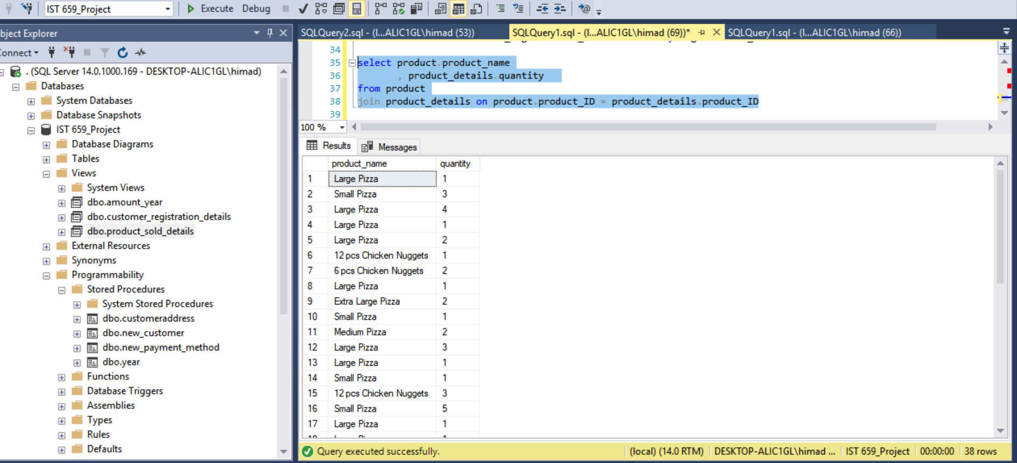

Question 2:

Use the database to compare the sale of current year to last year

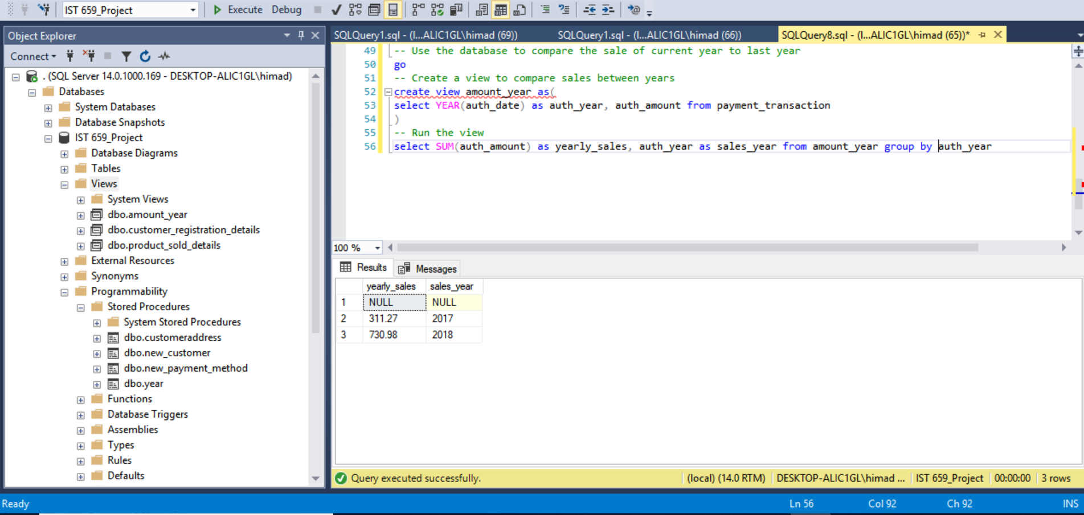

Question 3:

Comparison between guest and registered customer

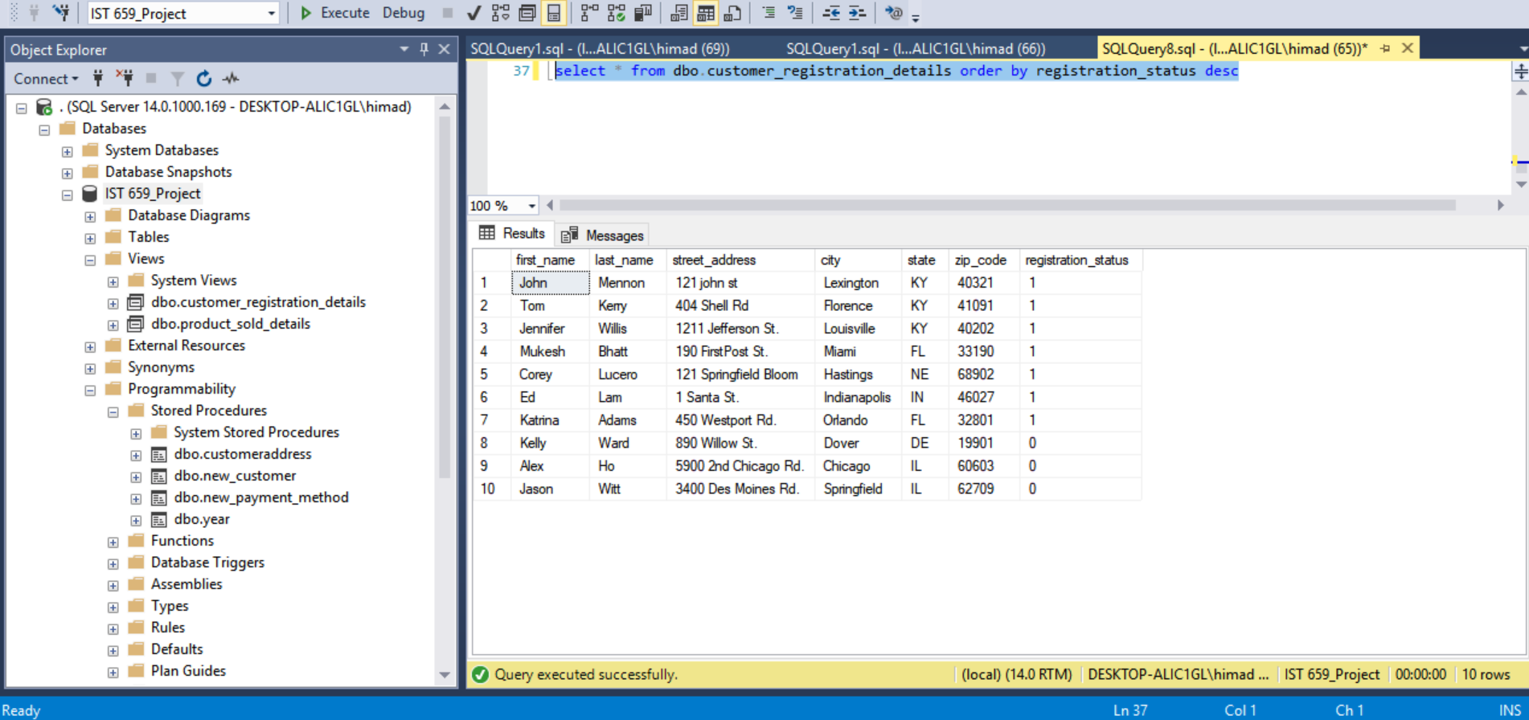

**GUI Prototype**

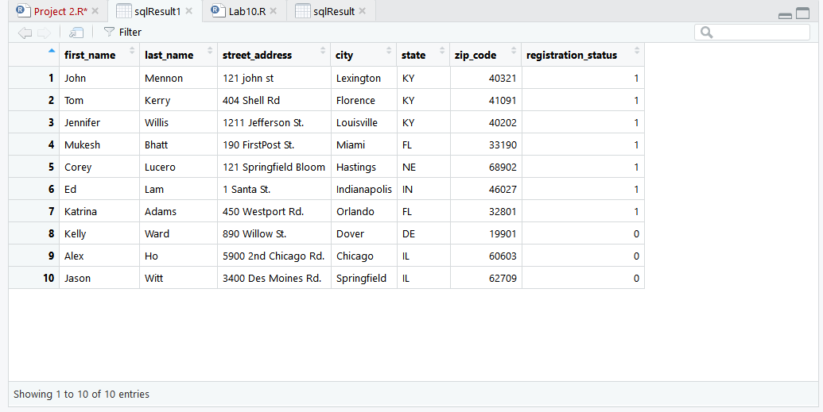

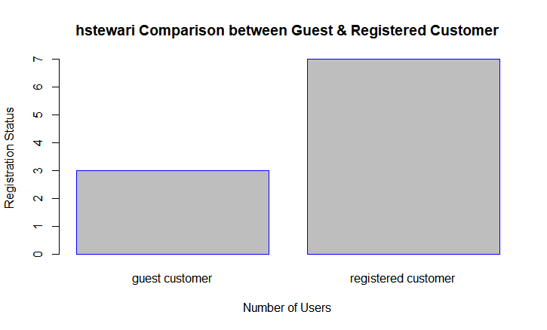

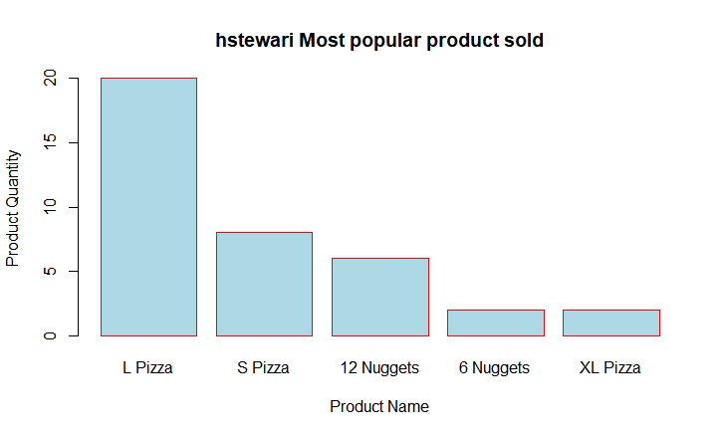

**# Ready RODBC for use in this script**

**require(RODBC)**

**#create a connection to SQL Server using 64-bit DSN**

**myconn <- odbcConnect("IST 659_Project")**

**#SQL statement to see customer address and registration status**

**sqlSelectStatement <-**

**"select \***

**from customer_registration_details**

**order by registration_status desc**

**"**

**# Send the request to the server and store the result in a variable**

**sqlResult <- sqlQuery(myconn, sqlSelectStatement)**

**# SQL query to compare between guest and registered customer**

**sqlSelectStatement1 <-**

**"**

**select \***

**from customer_registration_details**

**order by registration_status desc**

**"**

**# Send the request to the server and store the result in a variable**

**sqlResult1 <- sqlQuery(myconn, sqlSelectStatement1)**

**#Plot a bar chart of comparison between guest and registered customer**

**registrationCount <- table(sqlResult1$registration_status)**

**barplot(registrationCount,**

**main = "hstewari Comparison between Guest & Registered Customer",**

**ylab = "Registration Status",**

**xlab = "Number of Users",**

**border = "blue",**

**names.arg = registrationCount**

**)**

**# SQL query to to find out the most popular product sold**

**sqlSelectStatement2 <-**

**"**

**select**

**product.product_name**

**, product_details.quantity**

**from product**

**join product_details on product.product_ID = product_details.product_ID**

**"**

**# Send the request to the server and store the result in a variable**

**sqlResult2 <- sqlQuery(myconn, sqlSelectStatement2)**

**# Create a list of products**

**products <- c("L Pizza", "S Pizza", "12 Nuggets", "6 Nuggets",**

**"XL Pizza")**

**#Plot a bar chart to find out the most popular product sold**

**productQty <- table(sqlResult2$quantity)**

**barplot(productQty,**

**main = "hstewari Most popular product sold",**

**ylab = "Product Quantity",**

**xlab = "Product Name",**

**border = "red",**

**col = "light blue",**

**names.arg = products**

**)**

**# Close all connections**

**odbcCloseAll()**

**#Fin**